**Global air travel**

The aim of this report is to show why more and more people choose to travel by plane.

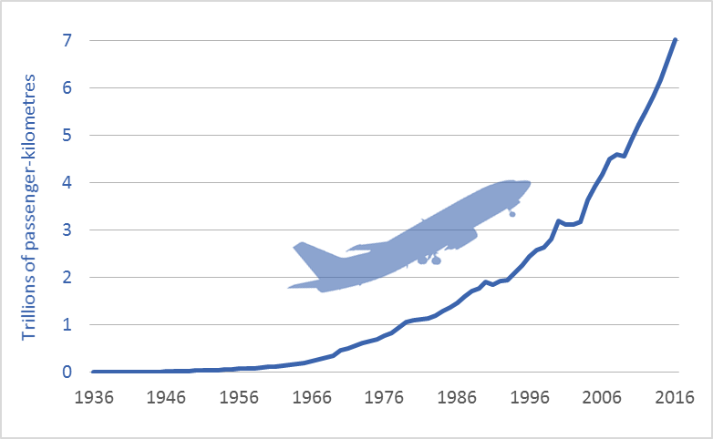

The graph shows that global air travel is increasing exponentially. In 2016, business travelers, tourists, and others traveled more than 7 trillion passenger-kilometers by air.

# But why are more and more people flying by plane?

One reason that there has been an increase in air travel is the growing market of low-cost airlines. You can already get tickets for 30 €. Another reason is that you can travel long distances in a short time by plane. For example, if you want to fly from Vienna to Berlin, it takes 1 hour and 10 minutes, additionally, you have to calculate time spent during boarding and deplaning. If you use the car, it would take you about 6 hours if there is no traffic jam. Many people also fly by plane because it is the safest mode of transport overall. Per billion travel kilometers, according to the most recent figures of the „Federal Statistical Office “ …. (where?), in the last four years, 0.3 people were injured in air travel, with railway it was 2.7 and the risk of being injured in car accidents hit 276 people.

# However, flying also has a bad side

An airplane causes a lot of noise. About a quarter of the population feels annoyed by noise pollution as caused by airplanes. Another serious argument against air travel is the kerosene consumed. The aircraft of the passenger fleets "Lufthansa" needed an average of only 3.68 liters of kerosene in 2017 to transport a passenger 100 kilometers. That is still a lot but has fallen by 4.5 percent in comparison to the previous year. If we compare the consumption of a plane with that of a car we see that on average, a car consumes 5-10 liters and a plane about 4 liters.

Another negative fact is that departure and arrival are dependent on the weather and therefore uncertain. For example, a flight is scheduled for take off at 12 o’clock. If there is a storm that flight might be delayed. And delays have become more frequent, not only because of the increase of extreme weather phenomena, but also because of drones obstructing air traffic and congested airways.

Conclusion:

The major reason why air travel is rising is the reduction in price. You can get a ticket for 30€. At the same time, more and more people are now in a position to afford air travel because fighting poverty has resulted in greater wealth around the globe. As long as these trends continue, prices will continue decreasing, passenger miles will be on the rise.

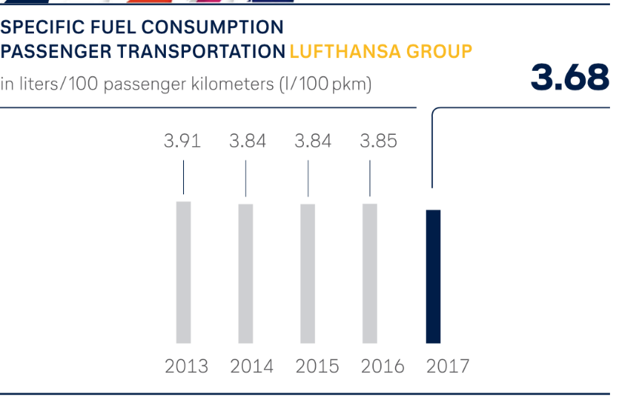

This is quite good, Gregoire. The ending is not so great, and the subheadings need to be more neutral, eg

# Air travel on the rise (not: But why are more and more people flying by plane?)

# Downsides (not: However, flying also has a bad side)